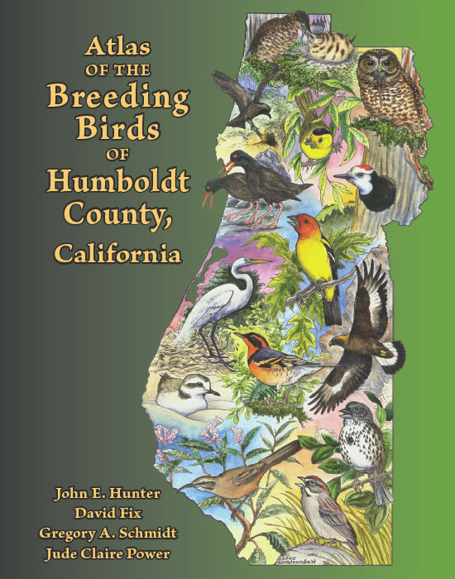
Artwork by Gary Bloomfield

Writer’s Note: I was a member of the Humboldt County Breeding Bird Atlas steering committee during the lion’s share of the 5 years of fieldwork. I left the project during its publication phase to devote time to other writing projects. My fellow steering committee members rewarded my efforts with an offer to pen the foreword. I include it here for two reasons: 1) The species accounts, written mainly by wildlife biologist David Fix, are an excellent example of science-literary hybrid writing, and 2) for those not familiar with the “Atlas of the Breeding Birds of Humboldt County,” published by Redwood Region Audubon Society, I encourage you to check it out.

Foreword

What you hold in your hands represents the first systematic effort to map the distribution of the birds that nest in Humboldt County. Fieldwork by both birders and professional biologists began in spring 1995 and concluded in fall 1999. The Atlas Steering Committee then tackled the monumental task of weaving together historical records, crates of data forms, distribution maps, published and “gray” literature, original illustrations, and comments from scientific reviewers and copy editors to create a finished product nearly 500 pages in length. On behalf of the birding community, I congratulate the many participants who contributed to this decade-long citizen science effort.

The local artists whose work graces these pages and the community members who commissioned drawings of their favorite breeding birds deserve a special thank you. These skillful renderings of more than 60 species add much to the publication’s appeal.

Humboldt County’s geographic isolation has kept it relatively unspoiled. Development here will never match the scale common in many other portions of the Golden State. Yet, the pace of life behind the Redwood Curtain has accelerated as well. Development here is inevitable. Establishing a baseline of breeding bird distribution is critical to understanding how these populations change in response to alteration or loss of habitat. Many people have chosen to live in Humboldt in reaction to having witnessed the overdevelopment occurring elsewhere in California. As a result, I think it’s fair to characterize the “Humboldt ethos” as one that acknowledges the natural beauty of this unique area and gives voice to a fervent desire to maintain open space and a high quality of life. I hope that this document will be widely used to aid in directing prudent, well-planned growth in synch with this ethos.

As mid-20th-century naturalist Joseph Wood Krutch said, “There is all the difference in the world between looking at something and living with it.” For the past ten years, those associated with the Atlas have truly lived with Humboldt. Atlasers slogged through wet meadows beneath its highest peaks to delineate the breeding grounds of Lincoln’s Sparrows. They hiked the idle railroad tracks through the Eel River Canyon, the point of discovery for Rufous-crowned Sparrows. They continued westward until the Pacific Ocean blocked their path, searching the sand dunes of Clam Beach for Snowy Plovers. They boarded a boat, bound for waters about the offshore rocks, trying to unlock the nesting secrets of seabirds such as the Rhinoceros Auklet.

I’d like to say several words about the value of the descriptive writing style that permeates the species accounts. Look around you: the natural world is being diminished daily. It needs all the allies it can get. Many of us are keenly aware of the graying of our birding constituency and how critical it is expose young minds to the vibrant and fascinating world of birds. Today, many distractions and temptations serve as barriers to experiencing the natural world. The written word can compete with cell phones, the internet, television, and video games if it is honest, takes chances, and – in this case – successfully evokes the sounds, sights, and smells of a mid-summer morning atlasing expedition. In my opinion, the Humboldt Atlas succeeds on all counts.

Those of us who consider ourselves defenders of wild places and the creatures that dwell there have reached a strategy crossroads. It seems that, as a culture, we are uncomfortable with scientists acting as advocates. We value the input of these experts, but feel that to be unbiased, their statements should be presented dispassionately, as disembodied third-person “tech-speak.” The problem with this “just the facts, ma’am” delivery is that it fails to convey why we should care about diminished habitats or their denizens. This is where the humanities come in. Writers, artists, photographers, and poets are adept at conveying the wonder and mystery of birds. I’m encouraged by the burgeoning body of literature that explores the cross-pollination between art and science. I consider the Atlas of the Breeding Birds of Humboldt County, California to be a significant addition to this genre.

Tom Leskiw
Atlaser and former Steering Committee member
(near) Eureka, California
February 2005

